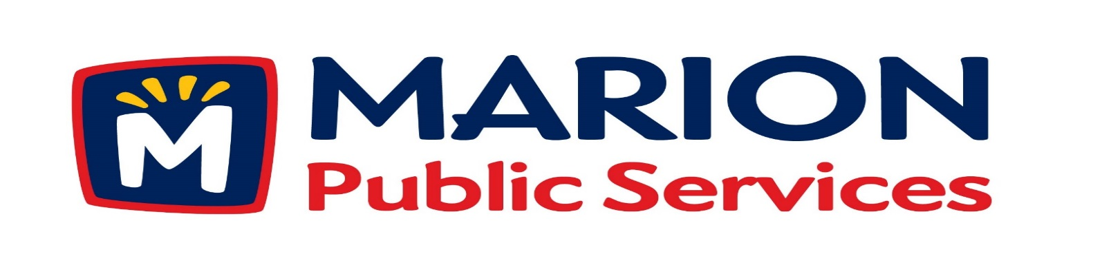

**Minutes**

**Public Services Board**

**City of Marion**

**Tuesday, May 10, 2015**

Present: Mark Morgan, Kevin Morgan, Colleen Prokop, Tom Padley, and Craig Adamson

Staff: Ryan Miller and Debbie Weber

1. Approval of April 2016 Minutes.
2. Motion to Approve Application for Solid Waste Fee Exemptions
   1. Floyd – 3365 Sunburst Avenue
3. Discussion regarding assistance for community events (Marion Arts Festival).
4. Motion to approve job description for Seasonal Maintenance Employee.
5. Update on Eco Industrial Park Development
6. Old Business/New Business.
7. Adjournment.

**Minutes**

**Public Services Board**

**City of Marion**

**Tuesday, May 10, 2015**

**Continued**

ITEM 1 Approval of March 2016 Minutes.

Craig Adamson called to order the regular meeting of the Public Service Board on Tuesday, May 10, 2016 at 12:10 PM. A motion to approve the April 2016 minutes was made by Mark Morgan, seconded by Kevin Morgan, approved by all, Motion carried.

ITEM 2 Motion to Approve application for Solid Waste Fee Exemption.

Mr. Lloyd on behalf of his father (Mr. Coffin) 3365 Sunburst Avenue submitted an exemption form. Mrs. Coffin passed away earlier this month and she was the caregiver to Mr. Coffin, whom has Alzheimer’s. Mr. Coffin was admitted to an assisted living center on May 2nd. The condo will be sold as soon as possible. A motion was made by Mark Morgan, seconded by Colleen Prokop to approve the applications, all members agreed, Motion carried.

ITEM 3 Discussion regarding assistance for community events (Marion Art Festival)

JMS Racing Services is requesting assistance of the Public Service Department again this year with the Marion Art Festival race. The following has been requested: change traffic lights to blinking red/yellow as needed, place no parking signs where appropriate, set up barricades as recommended by the Police Department, set up temporary stop signs as needed, and place cones on busier road ways to provide a sufficient running lane. The benefits to having our staff involved include, a safer event and helps the Police Department. The board discussed the amount of time and labor that would be involved and to charge accordingly. The board agreed to have Ryan move forward with this request.

**Minutes**

**Public Services Board**

**City of Marion**

**Tuesday, May 10, 2015**

**Continued**

Item 4 Motion to approve job description for Seasonal Maintenance Employee.

Ryan presented an updated job description for Public Service Seasonal Maintenance Employee. This update reflects a more accurate and detailed description of the current position. A motion was made to approve, made by Tom Padley, seconded by Colleen Prokop, approved by all, Motion carried.

ITEM 5 Discussion Regarding Development Agreement for Eco Development Park.

Ryan updated the PS Board regarding the Eco Park Development, the property of the future Eco Development Park has been purchased. Ryan discussed pelletized compost and the benefits of producing this at the new facility. Ryan also discussed the concept of recycling plastic into diesel fuel.

ITEM 6 Old Business / New Business

Nothing discussed.

ITEM 7 Adjournment

Meeting was adjourned at 1:46PM by Craig Adamson. A motion was made by Mark Morgan, seconded by Colleen Prokup, and all Board members are in favor, Motion carried.

Next PSB meeting is scheduled for Tuesday, June 14th, 2016 at noon.

**Minutes**

**Public Services Board**

**City of Marion**

**Tuesday, May 10, 2015**

**Continued**

Respectfully submitted by:

____________________

Ryan Miller

Public Service Director

RM/dsw