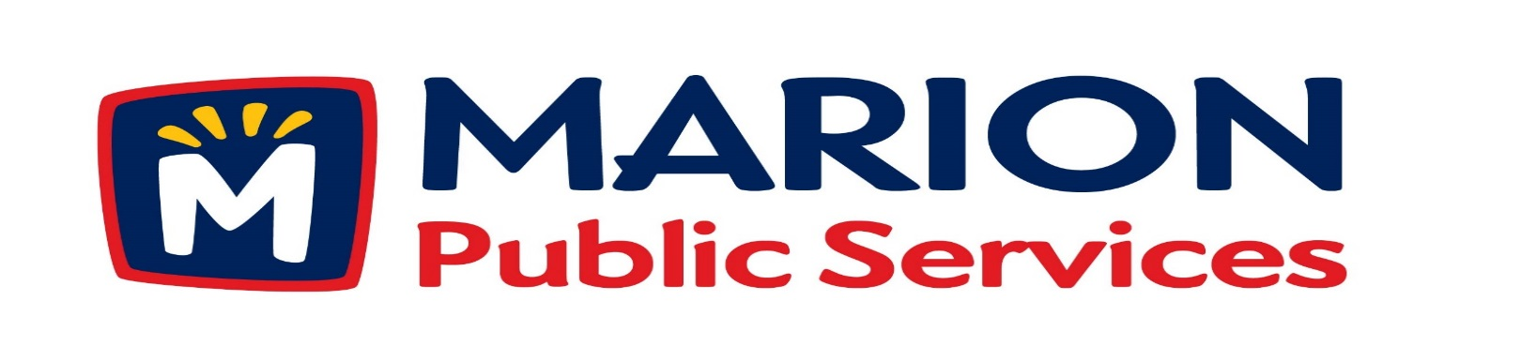

**Minutes**

**Public Services Board**

**City of Marion**

**Wednesday, December 13th, 2016**

Present: Kevin Morgan, Mark Morgan, Colleen Prokop, Tom Padley, and Craig Adamson

Absent: None

Staff: Ryan Miller and Diane Toy

1. Approval of November 2016 Minutes.
2. Motion to Approve the 2016/2017 Snow and Ice Program.
3. Discussion Regarding Open House and Receptions Policy.
4. Discussion Regarding Recycling Services.
5. Discussion Regarding Solid Waste Fees.
6. Update on Eco Industrial Development.
7. Old Business / New Business.
8. Adjournment.

**Minutes**

**Public Services Board**

**City of Marion**

**Wednesday, December 13th, 2016**

**Continued**

ITEM 1 Approval of November 2016 Minutes.

Craig Adamson called to order the regular meeting of the Public Service Board on Wednesday, December 13th, 2016 at 12:08 PM. A motion to approve the November 2016 minutes was made by Mark Morgan, seconded by Tom Padley, approved by all, Motion carried.

ITEM 2 Motion to Approve 2016/2017 Snow and Ice Program.

The polices are the same as last year, with the addition of Tower Terrace between 10th St and Winslow Rd – but the roadway is closed until the school gets city approval to install a fence. New changes are how we remove snow and sand the round abouts. We are still rated high on the Citizen survey with 93.2% - snow removal for major roadways, and 76% - snow removal for residential. We had winter weather training with staff the end of November and handed out new plow books. A motion was made by Mark Morgan, seconded by Tom Padley, to approve the 2016/2017 Snow and Ice Program, all members agreed, Motion carried.

ITEM 3 Discussion Regarding Open House and Receptions Policy.

Ryan talked to the PS Board about resolution 23153 about the policy of when you spend public money. Craig wants to talk about this in more detail at our next PS Board meeting and discuss what has been done in the past, what would be approved in the future. Would like examples of ideas and time frame. A motion was made by Craig Adamson to have Ryan look into this, seconded by Colleen Prokop, approved by all, Motion carried.

**Minutes**

**Public Services Board**

**City of Marion**

**Wednesday, December 13th, 2016**

**Continued**

ITEM 4 Discussion Regarding Recycling Services.

Ryan talked to the PS Board about a new company located in Medco Industrial Park called Quincy Recycling, they are located closer to our facility then the current place we are using. They take sorted recycling (i.e.: cardboard, and plastic) and will be installing a scale this month. At this time they do not take single stream recycling (curbside collection). We have started to use them and there are no contracts to sign to use their service.

Item 5 Discussion Regarding Solid Waste Fees.

Ryan updated the PS Board on the rate increases at the CR/LC Solid Waste Agency for the current year: Garbage - $38.00 to $40.00/ton

Recycling - $22.00 to $24.00/ton

TV’s < 19” - $10.00 each

TV’s > 19” - $15.00 each

There is a cost of some electronic items that were free. Ryan will have to review the fees to residents to see if the cost increase has affected our cost to residents and may have to increase rates. Ryan will update the PS Board on this item at a future meeting.

Craig Adamson left the meeting at 1:10PM, Mark Morgan to over the meeting.

ITEM 6 Update on the Eco Industrial Park.

Ryan updated the PS Board on the plans for the Eco Industrial Park. He is working with a steel building manufacturer who has their own architectures’ and engineers in house. When change requests are done they are returned to Ryan very quickly, so he is able to look at different layouts and is able to compare the designs. Ryan has a book with all the information and specifications and they have been very competitive cost wise. They are willing to work with local contractors, so Ryan is getting bids locally for havoc, sprinklers and electrical. Fueling station plans are moving along as to the size and services it will offer. Ryan will keep the PS Board updated on the progress and plans. No action needed at this time.

**Minutes**

**Public Services Board**

**City of Marion**

**Wednesday, December 13th, 2016**

**Continued**

ITEM 7 Old Business / New Business.

Ryan asked the PS Board to approve the request for house pick up for resident:

Terry Stark residing at 1890 27th Ave he is elderly and disabled. A motion was made by tom Padley, seconded by Colleen Prokop, to approve the request, all members agreed, Motion carried.

ITEM 8 Adjournment.

The meeting was adjourned at 1:45PM by Mark Morgan. A motion was made by Tom Padley, seconded by Colleen Prokop, approved by all, Motion carried.

Next PSB meeting is scheduled for Tuesday, January 10th, 2017 at noon.

Respectfully submitted by:

____________________

Ryan Miller

Public Service Director

RM/dpt