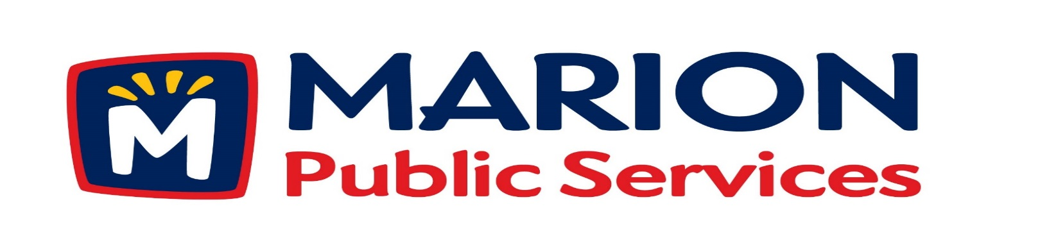

**Minutes**

**Public Services Board**

**City of Marion**

**Wednesday, February 14th, 2016**

Present: Colleen Prokop, Kevin Morgan, Mark Morgan, Tom Padley, and Craig Adamson

Absent: None

Staff: Ryan Miller and Diane Toy

1. Approval of January 2017 Minutes.
2. Motion to Approve Solid Waste House Pickup Request.

a. Blackman 2796 14th Avenue

1. Discussion Regarding Open House, Receptions, and Employee Recognition Policy.
2. Discussion Regarding 2017/2018 Budget.
3. Update on Eco Industrial Park Development.
4. Old Business / New Business.
5. Adjournment.

**Minutes**

**Public Services Board**

**City of Marion**

**Wednesday, February 14th, 2016**

**Continued**

ITEM 1 Approval of January 2017 Minutes.

Craig Adamson called to order the regular meeting of the Public Service Board on Wednesday, February 14th, 2017 at 12:05 PM. A motion to approve the January 2017 minutes was made by Mark Morgan, seconded by Tom Padley, approved by all, Motion carried.

ITEM 2 Motion to Approve Solid Waste House Pickup Request.

The following residents have requested Solid Waste House collection a service we provide for handicap or elderly residents. The Blackman’s residing at 2796 14th Avenue has health issues and is elderly. This maybe temporary and Ryan will follow up with the Solid Waste Supervisor. A motion was made by Craig Adamson, seconded by Tom Padley, to approve the request, all members agreed, Motion carried.

ITEM 3Discussion Regarding Open House, Receptions, and Employee Recognition Policy.

Ryan talked to the PS Board about the Policy that was talked about in November 2016 and that the City Council approved a Resolution #23153 in May 2013 so a policy is on the books. The PS Board talked about extending anything we do is open to the public. Mark is in favor of this policy, Craig had questions on Section 3 #1 but after discussion felt this covers any employee recognition. Craig also talked about item #3 and discussed if the PS Board was to send out a Boucher / handout would this cover the cost, it was decided yes. A motion was made by Mark Morgan, seconded by Colleen Prokop to approve the policy, approved by all, Motion carried.

**Minutes**

**Public Services Board**

**City of Marion**

**Wednesday, February 14th, 2016**

**Continued**

ITEM 4 Discussion Regarding 2017/2018 Budget.

Ryan talked to the PS Board about the draft of the 2017/2018 budget with the PS Board, each member was given a copy of the Budget and Ryan went over the numbers pertaining to the Public Service Department. Ryan will keep the PS Board informed about changes and the final budget. Tim Oswald from Piper Jaffrey talked at the 2/9/17 City Council Meeting explaining financing for Eco Park. Ryan updated the PS Board on Operator needs due to the growth of the city. The City did a Special Census due to growth and the City will see an additional return in the Road Use fund. Ryan talked about changing some positions within the Public Service Department so there can be some internal promotions and have more employees eligible for Pay for Performance. Healthcare is a concern, but the City can only offer what it can and everyone has the same coverage

Item 5 Update on Eco Industrial Park Development.

Ryan updated the PS Board on the plans for the Eco Industrial Park and went over the book he had put together for the City Council and the power point that he was presenting to them at the City Council Work session on February 10th, 2017 and how the budget will work for the Eco Industrial Park. He talked about the how the payments will stay the same for at least 10 years and how he is planning for growth of the size of the fleet. Asked if the PS Board had any Questions/Thoughts/Concerns: Craig feels Ryan is being very conservative & thinking of any worse case plan and Craig feels this is a good path to take. The plan for the Eco Industrial Park is going to the Planning and Zoning Board on 2/14/17 and Ryan will attend the meeting in case there are any questions, Part of the land is still in the county and has to be annexed Ryan is working on the timeline for the project and will update the PS Board as information is available.

**Minutes**

**Public Services Board**

**City of Marion**

**Wednesday, February14th, 2016**

**Continued**

ITEM 6 Old Business / New Business.

1204 Building – Asked for TIF after building is complete.

Talked about new Fire Station.

State of the City Lunch – Mark, Tom and Kevin - NO, Craig and Colleen – YES.

ITEM 8 Adjournment.

The meeting was adjourned at 1:24 PM by Craig Adamson. A motion was made by Mark Morgan, seconded by Tom Padley, approved by all, Motion carried.

Next PSB meeting is scheduled for Tuesday, March 14th, 2017 at noon.

Respectfully submitted by:

____________________

Ryan Miller

Public Service Director

RM/dpt