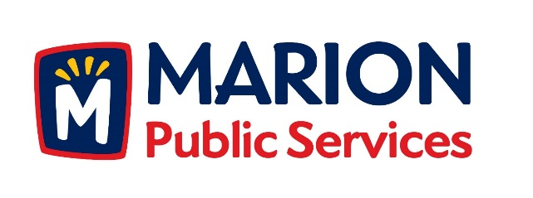

**CITY OF MARION PUBLIC SERVICE BOARD**

**AGENDA**

**Noon**

**March 21, 2017**

1. Approval of February 2017 Minutes.
2. Motion to Approve Solid Waste House Pickup Requests.
   1. Harper-1539 5th Avenue
3. Discussion Regarding Eco Industrial Park Development.
4. Motion to Direct Staff to Complete Financing and Project Documents for the Eco Industrial Park Development.
5. Old Business/New Business.
6. Adjournment.