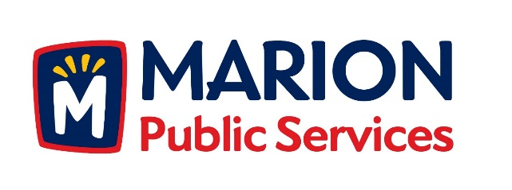

**CITY OF MARION PUBLIC SERVICE BOARD**

**AGENDA**

**Noon**

**April 11th, 2017**

1. Approval of March 2017 Minutes.
2. Motion to Approve the Public Service Work Schedule for 2017.
3. Discussion Regarding Strategic Goals for the Public Services Department.
4. Discussion Regarding Wastewater Treatment Agreement with the City of Cedar Rapids.
5. Old Business/New Business.
6. Adjournment.