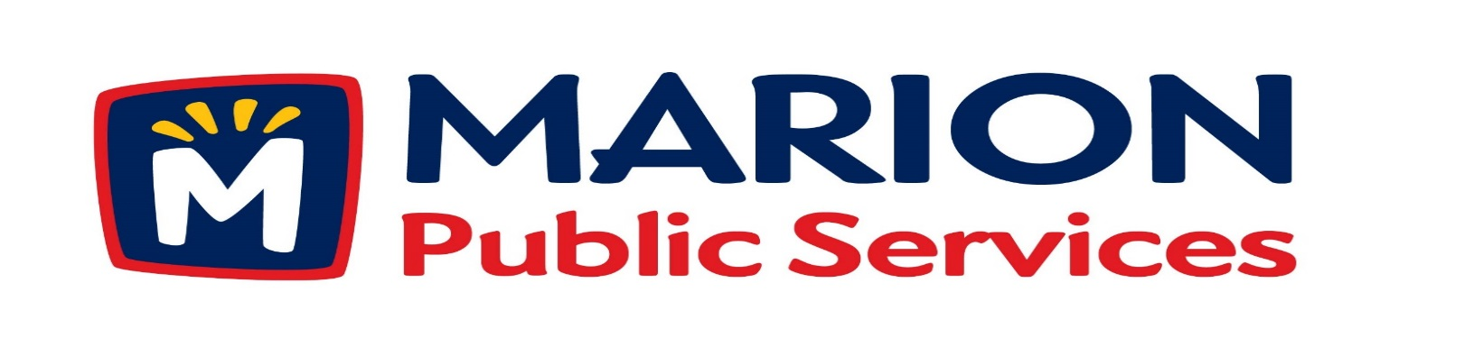

**Minutes**

**Public Services Board**

**City of Marion**

**Tuesday, August 11th, 2017**

Present: Craig Adamson, Tom Padley, Colleen Prokop, and Kevin Morgan

Absent: Mark Morgan

Staff: Ryan Miller and Diane Toy

1. Approval of July2017 Minutes.
2. Motion to approve House Pickup Request.
   1. Newhall-4412 Pepperwood Hill SE
3. Discussion Regarding Project Delivery for the Eco industrial Park.
4. Old Business / New Business.
5. Adjournment.

**Minutes**

**Public Services Board**

**City of Marion**

**Tuesday, August 11th, 2017**

**Continued**

ITEM 1 Approval of July 2017 Minutes.

Craig Adamson called to order the regular meeting of the Public Service Board on Tuesday, August 11th, 2017 at 12:01 PM. A motion to approve the June 2017 minutes was made by Tom Padley, seconded by Kevin Morgan, approved by all, Motion carried.

ITEM 2 Motion to approve House Pickup.

Ryan updated the PS Board that the house pick up at 4412 Pepperwood Hill SE, the resident is elderly and cannot get the garbage to the curb safely. The Solid Waste Supervisor went to the residence’s home and has recommended the service for the resident. Craig asked Ryan for an update on the house pick at 1609 3rd Ave if there were any questions and if Ryan spoke with the City Manager, Ryan updated not questions and house pick up is okay. A motion was made by Craig Adamson, seconded by Kevin Morgan, all members agreed, Motion carried.

ITEM 3 Discussion Regarding Project Delivery for the Eco Industrial Park.

Ryan updated the PS Board on the bid for the Early Grading of the Eco Industrial Park. There were 6 companies that bid the project. Rathje was awarded the bid with a bid of $140,943.50 due to the fact they are charging $1.00 for mobilization, the next closest bid was from Rickfels at $148,777.00. The project has to be completed in 60 days and work must start by August 28th, 2017, and will incur a $500.00 per day fine after the 60 days. The site is under the control of DNR and Corp of Army Engineers for 4 years, we hold the permit to control the soil, wetlands, swift and erosion. Ryan is looking at different ways to have the project controlled and will have the PS Board look at the various ways Construction Manager at Risk (CMAR), Design, Bid, Build or Design, Build, Lease Purchase.

**Minutes**

**Public Services Board**

**City of Marion**

**Tuesday, August 11th, 2017**

**Continued**

ITEM 3 Discussion Regarding Project Delivery for the Eco Industrial Park continued.

Ryan also updated the PS Board on the order of business for the project. First RFQ, then RFP – then you use a score card to rate the proposals. Ryan asked if anyone from the PS Board would like to be a part of the RFQ from the start and work through the RFP with or after staff looks at them. The PS Board would be a part of the final selection. The process should take about 6 weeks and Kevin would like to be a part of the team from start to finish decision with staff. A motion was made by Tom Padley, seconded by Colleen Prokop to send out the RFQ and RFP and the PS Board will make the final decision, will then go to the City Council for approval, approved by all, Motion carried.

ITEM 4 Old Business / New Business.

Ryan updated the PS Board about the plans for the library (old / new), parking and strip mall and current uptown businesses affected by the demolition of the strip mall.

ITEM5 Adjournment.

The meeting was adjourned at 12:55 PM by Craig Adamson. A motion was made by Colleen Prokop, seconded by Tom Padley, approved by all, Motion carried.

Next PSB meeting is scheduled for Tuesday, September 12th, 2017 at noon.

Respectfully submitted by:

____________________

Ryan Miller

Public Service Director

RM/dpt