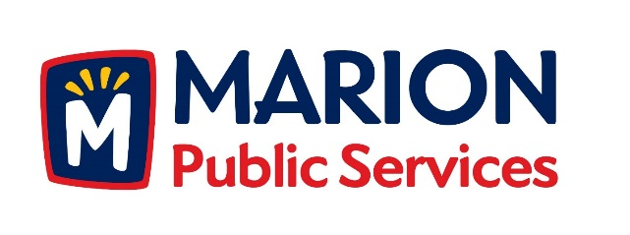

**CITY OF MARION PUBLIC SERVICE BOARD**

**AGENDA**

**Noon**

**August 8th, 2017**

1. Approval of July 2017 Minutes.
2. Motion to Approve House Pickup Request.

-Newhall-4412 Pepperwood Hill SE

1. Discussion Regarding Project Delivery for the Eco Industrial Park.
2. Old Business/New Business.
3. Adjournment.