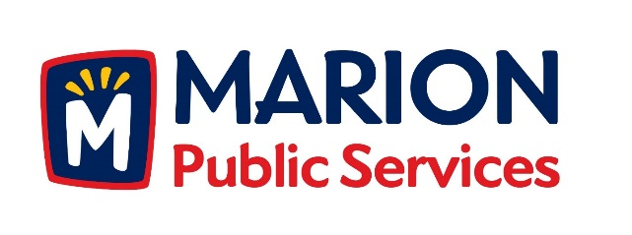

**CITY OF MARION PUBLIC SERVICE BOARD**

**AGENDA**

**Noon**

**April 10th, 2018**

1. Motion to approve the March 2018 Minutes.
2. Motion to approve residency waiver for Mike Devlin.
3. Motion to approve application for house pickup services:

a. Melcherd-2400 23rd Avenue

1. Motion to Approve Request for Solid Waste Exemption.

a.Lange-261 Larick Drive

1. Motion to approve the 2018 work schedule for the Public Services Department.
2. Update on the Eco Industrial Park.
3. Old Business/New Business.
4. Adjournment.