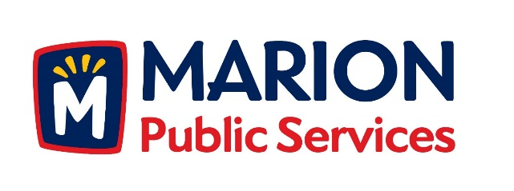

**CITY OF MARION PUBLIC SERVICE BOARD**

**AGENDA**

**Noon**

**May 8th, 2018**

1. Motion to approve the April 2018 Minutes.
2. Review of Solid Waste Rates for Commercial Collection Services.
3. Discussion regarding Request for Proposals for Construction Manager Services.
4. Old Business/New Business.
5. Adjournment.