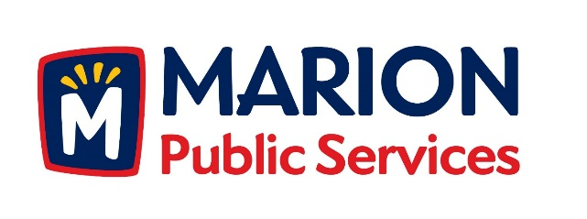

**CITY OF MARION PUBLIC SERVICE BOARD**

**AGENDA**

**Noon**

**June 19th, 2018**

1. Motion to approve the May 2018 Minutes.
2. Discussion regarding Phase I of the Eco Industrial Park.
3. Motion to approve Knapp Warden as Construction Manager for the Public Service Maintenance Facility.
4. Update on Solid Waste Rates for Commercial Collection Services
5. Old Business/New Business.
6. Adjournment.