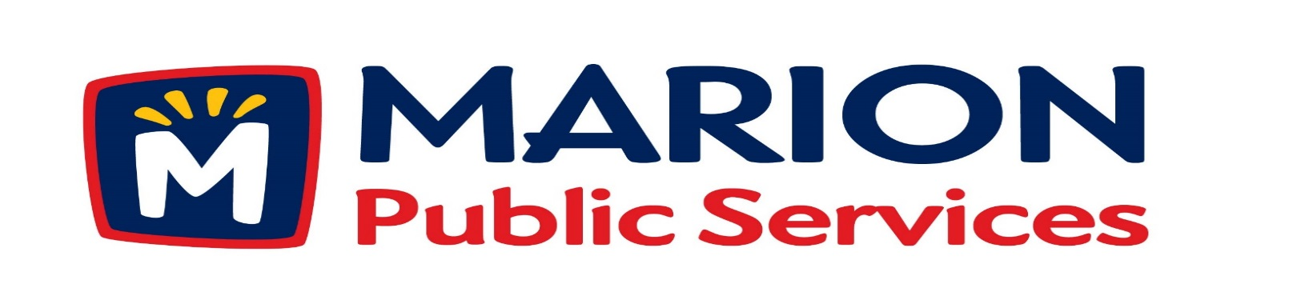

**Minutes**

**Public Services Board**

**City of Marion**

**Tuesday, June 19, 2018**

Present: Colleen Prokop, Tom Padley, and Craig Adamson

Absent: Kevin Morgan and Mark Morgan

Staff: Ryan Miller and Diane Toy

1. Motion to approval of May 2018 Minutes.
2. Discussion regarding Phase I of the Eco Industrial Park.
3. Motion to approve Knapp Warden as Construction Manager for Public Service Maintenance Facility.
4. Update on Solid Waste Rates for Commercial Collection Services.
5. Old Business / New Business.
6. Adjournment.

**Minutes**

**Public Services Board**

**City of Marion**

**Tuesday, June 19, 2018**

**Continued**

ITEM 1 Approval of May 2018 Minutes.

Craig Adamson called to order the regular meeting of the Public Service Board on Tuesday, June 19th, 2018 at 12:05PM. A motion to approve the May 2018 minutes was made by Tom Padley, seconded by Colleen Prokop, approved by all, Motion carried.

ITEM 2 Discussion regarding Phase I of the Eco Industrial Park.

Ryan updated the PS Board that there will be a Special Session with the City Council on Thursday the 16th of June for Ryan to talk to the City Council about the Eco Industrial Park project. Ryan was given the green light by the City Council to move forward with the project. The project will be funded by 7 million in revenue bonds with a breakdown of 3.5 mil to Road Use, 1.75 mil to Solid Waste, and 1.75 mil for Sewer. The Maintenance facility with have a storm shelter and will be able to function as an Emergency center for Police, Fire and Public Service departments. The building will have a life span of 30 to 40 years of operation and growth. The Weidt Group is doing an energy efficiency testing that is being paid for by Mid Am and Alliant. We are looking into geothermal and renewable energy sources and are doing a solar study. We are also looking at the maintenance of vehicles over a four year period between diesel and CNG engines. Ryan talked about the CNG filling station that the gas lines are buried and that the CNG compressors will be stored in a masonry structure and how steady the prices of CNG have been over the last 8 years. Ryan has money in reserves for fleet replacement due to delayed replacement of current fleet. The City Council wants Ryan to look into automated solid waste collection and leaf collection, we now pick up 4- 7 tons of solid waste per truck and use 4 to 5 trucks per day with an average of 500 residents per truck. Ryan will give the PS board updates and continue to talk about changes to the Public Service fleet and services.

**Minutes**

**Public Services Board**

**City of Marion**

**Tuesday, June 19, 2018**

**Continued**

ITEM 3 Motion to approve Knapp Worden as the Construction Manager for the Public Service Maintenance Facility.

Ryan talked about Knap Worden’s qualifications and showed the comparison of the 3 bids received. Knapp Worden will charge a flat fee of 4% and they oversee the bids and work of the subs but the subs will work for the City of Marion. Knapp Warden was the only contractor that sat down with Ryan to talk about the project and listen to what we were looking for in the project and explained the process to him. A motion was made by Tom Padley to move forward with Knapp Warden as the Construction Manager, seconded by Colleen Prokop, approved by all members, Motion carried.

ITEM 4 Old Update on Solid Waste Rates for Commercial Collection Services

Ryan followed up with the PS Board about the Uptown collection questions from last month. We sent letters to the businesses and residents that had questions and the response was they do not want to pay or use the service. Ryan would like to uphold the same rules as residential customers: you have to pay for the service even if you elect not to use it. The City Council may want to review the rates again at a later date, once there are more restaurants online we will look into the rates currently being charged.

ITEM 5 Old Business / New Business.

Public service has posted the following jobs: Equipment Operator, Utility Maintenance Specialist and an Assistant Public Service Director.

Public Service will be doing some Strategic Planning in July.

50 Veteran banners were ordered and we will put them up before the 4th of July.

Marion has 30 firework vendors licensed with the City of Marion.

**Minutes**

**Public Services Board**

**City of Marion**

**Tuesday, June 19, 2018**

**Continued**

ITEM 6 Adjournment.

The meeting was adjourned at 1:10 PM by Craig Adamson. A motion was made by Colleen Prokop, seconded by Tom Padley, approved by all members, Motion carried.

Next PS Board meeting is scheduled for Tuesday, July 10th, 2018 at noon.

Respectfully submitted by:

____________________

Ryan Miller

Public Service Director

RM/dpt