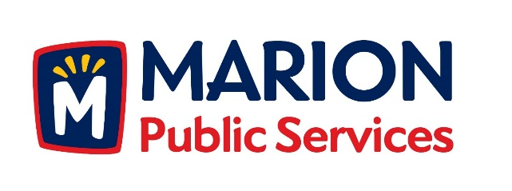

**CITY OF MARION PUBLIC SERVICE BOARD**

**AGENDA**

**Noon**

**December 11th, 2018**

1. Motion to approve the November 2018 Minutes.
2. Discussion regarding storm water improvements at 2401 Indian Creek Road (Indian Creek Country Club).
3. Discussion regarding the Public Service Maintenance Facility.
4. Review of 2019-2020 Fiscal Year Budget.
5. Discussion regarding vacancy for the Public Services Board.
6. Old Business/New Business.
7. Adjournment.