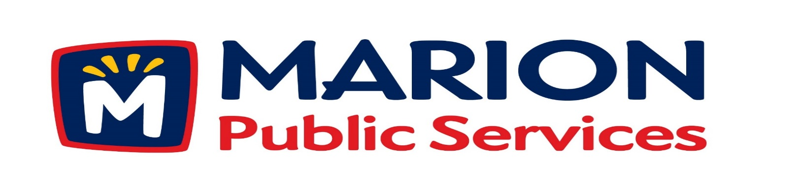

**Minutes**

**Public Services Board**

**City of Marion**

**Tuesday, November 13th, 2018**

Present: Colleen Prokop, Tom Padley, Mark Morgan, and Craig Adamson arrived at 12:25PM

Absent: Kevin Morgan

Staff: Ryan Miller and Diane Toy

1. Motion to approve the October 2018 Minutes.
2. Motion to approve the 2018-2019 Snow Removal Program.
3. Review of the proposed 2018 Capital Improvement Program.
4. Update on Phase I of the Eco Industrial Park.
5. Old Business/New Business.
6. Adjournment.

**Minutes**

**Public Services Board**

**City of Marion**

**Tuesday, November 13th, 2018**

**Continued**

ITEM 1 Approval of October 2018 Minutes.

Mark Morgan called to order the regular meeting of the Public Service Board on Tuesday, November 9th, 2018 at 12:05PM. A motion to approve the October 2018 minutes was made by Tom Padley, seconded by Colleen Prokop, approved by all, Motion carried.

ITEM 2 Approve the 2018-2019 Snow Removal Program.

Ryan updated the PS Board update the PS Board on the 2018-2019 Snow Removal Program, not much has changed we have some new residential streets and Twixt Town Rd is now Cedar Rapids . The City of Alburnet has talked to us about doing snow removal for them. No decision was made at this point no action needed. In 8 hours we can plow and sand the whole City of Marion with 2.5” of snow, residential are a priority 2 area to be plowed and take from 1 ½ - 2 ½ hours to plow and sand, we do one pass in cul du sacs with the residential and clearing the cul du sacs are a priority 3, City alleyways are apriority 4 and done last. Each year we do snow plow training and last year we did a driving course, this helps the new drivers get familiar with our equipment and is a fun competition. The Citizen survey which is done every 2 years shows snow removal is the high rated service. We have the same polices this year as in prior years, and will go to the City Council for approval by resolution. A motion was made by Mark Morgan to approve and send to the City Council, seconded by Colleen Prokop, approved by all members, Motion carried.

**Minutes**

**Public Services Board**

**City of Marion**

**Tuesday, November 13th, 2018**

**Continued**

ITEM 3 Review of the proposed 2018 Capital Improvement Program.

Ryan talked to the PS Board about the Capital Improvement Program (CIP) for the City of Marion for the 5 year plan. Some of the money is from the following funds: LOST, BONDS or grants for the trails. The City Council is talking about different ways to fund the CIP programs in the future. Public Service and the Engineering Department are working together on future work programs to coordinate projects to help save resources and money.

ITEM 4 Update on Phase I of the Eco Industrial Park.

Ryan update the PS Board on the progress of Phase I of the Eco Industrial Park, we received approval from the Corp of Engineer to move forward. The Parks Department has submitted a grant for the Butterfly Project in all the wetlands on the property. We are looking at installing a large geothermal field. Ryan and the architect and Project Manager are talking about the front office being per-cast, but also looking at the cost for the whole building to be pre-cast because the current plan is designed so good there maybe condensation problems. Pre-cast will keep moisture out of the insulation in the roof. The overhead door size will be 18’ x 18’ which are bigger than the current doors of 14’ x 16’ and they will be counter weight doors. The project is moving along and still within budget. Ryan will keep the PS board updated on the progress of the project and have Knapp Worden present to the PS Board at a later date.

ITEM 5 Old Business / New Business.

Update on the Library project which will be about 46,000 sq. ft. and have residential unit above it with retail on the ground floor off 7th Ave. Parking garage has 2 design plans one is ½ block and the other is the full block.

Reappointment for 2019-2020 Tom Padley – Yes, Mark Morgan – Yes, Collen Prokup – Yes

**Minutes**

**Public Services Board**

**City of Marion**

**Tuesday, November 13th, 2018**

**Continued**

ITEM 6 Adjournment.

The meeting was adjourned at 1:15 PM by Mark Morgan. A motion was made by Tom Padley, seconded by Craig Adamson, approved by all members, Motion carried.

Next PS Board meeting is scheduled for Tuesday, December 11th, 2018 at noon.

Respectfully submitted by:

____________________

Ryan Miller

Public Service Director

RM/dpt