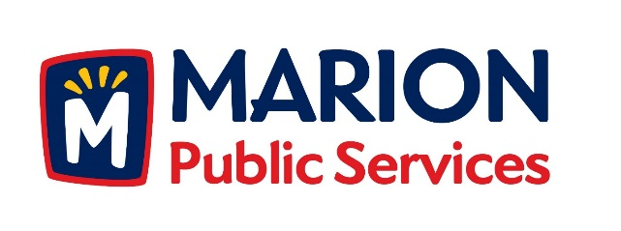

**CITY OF MARION PUBLIC SERVICE BOARD**

**AGENDA**

**Noon**

**January 8th, 2019**

1. Motion to approve the December 2018 Minutes.
2. Motion to approve the 2019 Solid Waste Holiday Collection Calendar.
3. Motion to Receive and File the Commercial New Construction Program Report from The Weidt Group.
4. Discussion regarding the Public Service Maintenance Facility.
5. Motion to Approve Letter of Intent with Sustane Technologies.
6. Old Business/New Business.
7. Adjournment.