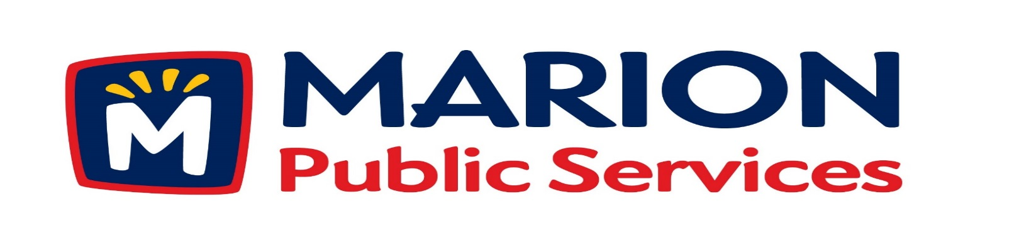

**Minutes**

**Public Services Board**

**City of Marion**

**Tuesday, May 14th, 2019**

Present: Tom Padley, Colleen Prokop, and Mark Morgan

Absent: Craig Adamson and Joe Spinks

Guest: Randy Strnad – Marion City Council

Staff: Ryan Miller and Diane Toy

1. Motion to Approve the May 2019 Minutes.
2. Motion to approve the 2019 Public Service Work Program.
3. Discussion regarding Solid Waste and Sanitary Fee Schedules.
4. Update on Phase I of the Eco Industrial.
5. Old Business/New Business.
6. Adjournment.

**Minutes**

**Public Services Board**

**City of Marion**

**Tuesday, May 14th, 2019**

**Continued**

ITEM 1 Approval of April 2019 Minutes.

Mark Morgan called to order the regular meeting of the Public Service Board on Tuesday, May 14th, 2019 at 12:06PM. A motion to approve the April 2019 minutes was made by, Colleen Prokop seconded by Tom Padley, approved by all, Motion carried. Randy Strnad arrived at 12:10PM.

ITEM 2 Motion to approve the 2019 Public Services Work Program.

Ryan talked to the PS Board about the work program and that they would approve the frame work of the work program. Ryan updated the PS Board on the pavement conditions after a very hard winter, it was very hard on the roads. Some years we are just repairing flare-ups that happen in the cold or very high heat, so not everything in the work program gets done. This winter we had blow-ups on Eastview and Williams that we had to address right away and we had other roads that have problems that we will have to address. At fire Station #2 the new Ariel truck sank into the driveway and we have to repair that as soon as possible. We are busy with right away sweeping, street sweeping, crack sealing and overnight painting. We like to have the uptown painting complete before the Marion Arts Festival. We will also be doing smoke testing for the sewer department. The sump pumps at City Hall failed so we were busy getting that repaired. A motion was made by Mark Morgan to approve the framework of the 2019 Public Service Work Program, approved by Tom Padley, seconded by Colleen Porop, approved by all members, Motion carried.

**Minutes**

**Public Services Board**

**City of Marion**

**Tuesday, May 14th, 2019**

**Continued**

ITEM 3 Discussion regarding Solid Waste and Sanitary Sewer Fees Schedule.

Ryan talked about how we have to raise our sewer fees to have the revenue to pay the O & M bill to Cedar Rapids each month. Ryan would like to see a service fee per water meter and add fees for multiple users on one meter. The fees would include a service fee (per water meter), a replacement fee and a user fee. Ryan will propose to the City Council increasing the monthly domestic user charges from $2.30 to $3.80 and reducing the service charge from $8.00 to $2.00. Ryan will present to have solid waste fees be raised from $14.50 to $15.50 and we will have to increase the special pick up fees due to the increased cost of taking items to the land fill, currently the fee is $30.00 and he would like to increase it to $40.00 and extra bag tags will be increased from $2.00 to $2.50. A motion was made by Tom Padley to approve the discussion to look into raising both Solid Waste and Sanitary Sewer fees, seconded by Colleen Prokop, approved by all members, Motion carried.

ITEM 4 Update on Phase I of the Eco Industrial Park.

Ryan update the PS Board on that the water lines are being installed by the Marion Water Department now. The civil bids are due back by 5/16/2019 and the public hearing is on 5/23/2019. The cost increase was due to the geothermal system and the size of the generator, which will be a backup and the facility will be on interruptible electric service. The City Council has approved the time line for the building to be complete. Ryan said there is a lot of interest in our current building and we should be able to sell it.

ITEM 5 Old Business / New Business

No race for the Marion Arts Festival.

Sustane is fully operational and will be sending samples for us to test.

**Minutes**

**Public Services Board**

**City of Marion**

**Tuesday, May 14th, 2019**

**Continued**

ITEM 6 Adjournment.

The meeting was adjourned at 1:23PM by Mark Morgan. A motion was made by Tom Padley, seconded by Colleen Prokop, approved by all members, Motion carried.

Next PS Board meeting is scheduled for Tuesday, June 11th, 2019 at noon.

Respectfully submitted by:

____________________

Ryan Miller

Public Service Director

RM/dpt