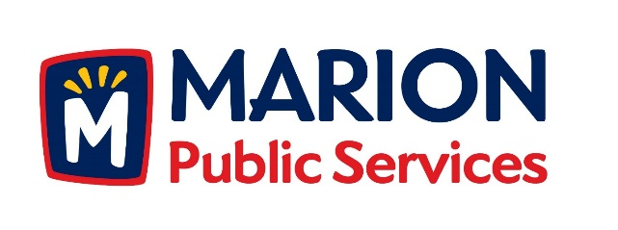

**CITY OF MARION PUBLIC SERVICE BOARD**

**AGENDA**

**Noon**

**June 11th, 2019**

1. Motion to approve the May 2019 Minutes.
2. Motion to approve the Equipment Rate Schedules.
3. Update on Wastewater Treatment Agreement
4. Updates on the Public Service Maintenance Facility.
5. Old Business/New Business.
6. Adjournment.