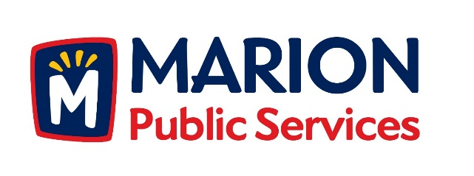

**CITY OF MARION PUBLIC SERVICE BOARD**

**AGENDA**

**Noon**

**July 9th, 2019**

1. Motion to approve the June 2019 Minutes.
2. Motion to approve fees for bulk item collections.
3. Discussion Regarding 28E Roadway Maintenance Agreement with Linn County.
4. Updates on the Public Service Maintenance Facility.
5. Old Business/New Business.
6. Adjournment.