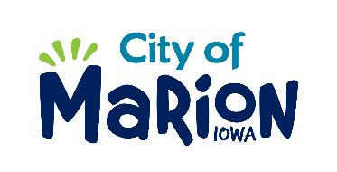 | PUBLIC SERVICE BOARD AGENDA  TUESDAY, FEBRUARY 11TH, 2020 – 12:00 p.m.  MARION PUBLIC SERVICES  195 35TH STREET, Marion, IA 52302

- Call to Order

- Roll Call

- Motion approving the minutes from the January 2020 Public Service Board Meeting.

- Motion to approve request for supplemental solid waste collection services.

  - Silva-2305 11th Avenue

- Discussion regarding single stream recycling program.

- Update regarding Eco Industrial Park.

- Discussion regarding Public Services Deputy Director position.

- Other Business

- Adjourn

