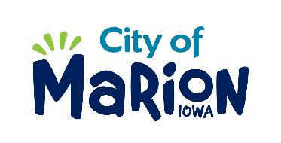 | PUBLIC SERVICE BOARD AGENDA  Tuesday, June 9th , 2020 – 12:00 p.m.  MARION PUBLIC SERVICES  195 35TH STREET, Marion, IA 52302

- Call to Order

- Roll Call

- Motion approving the minutes from the March 2020 Public Service Board Meeting.

- Motion to approve request for House Collection Services.

  - Perterson-3450 24th Avenue
  - Engel-3230 Sunburst Avenue
  - Scholbrach-3160 28th Avenue

- Motion to consider claim for damaged refuse container.
  - Boyd-457 Barrington Parkway

- Motion to Approve the 2020 Public Service Work Program.

- Motion to adjourn to closed session regarding litigation as permitted under Section 21.5 (1) (C ) of the Code of Iowa.

- Other Business

- Adjourn

