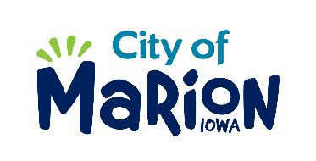 | PUBLIC SERVICE BOARD AGENDA  Tuesday, December 15th, 2020 – 12:00 a.m.  Marion City Hall

- Call to Order

- Roll Call

- Motion approving the minutes from the November 2020 Public Service Board Meeting.

- Motion to approve request for House Collection Services.

  - Norton-5055 Northridge Point

- Discussion regarding Emergency Waterway Debris Removal Project.

- Discussion regarding FY22 Budget.

- Discussion regarding Public Service Facilities Project.

- Other Business

- Adjourn

