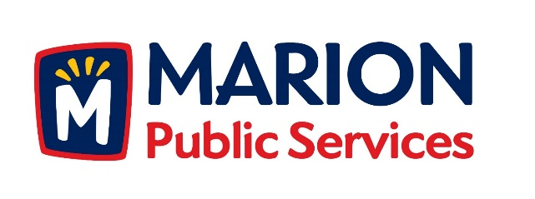

**CITY OF MARION PUBLIC SERVICE BOARD**

**AGENDA**

**Noon**

**September 8th, 2015**

1. Approval of August Minutes.
2. Motion to Approve House Pickup Request.
   1. Kula-980 27th Street
3. Motion to Approve Waiver of Solid Waste Fees-Unit Vacancy
   1. Berridge-2139 Echo Hill Road

4. Presentation on Public Service Integrated Fleet Technologies

5. Discussion on proposals for Public Service Chassis Development Program.

1. Update on Public Service Facility Development.
2. Old Business/New Business.
3. Adjournment.