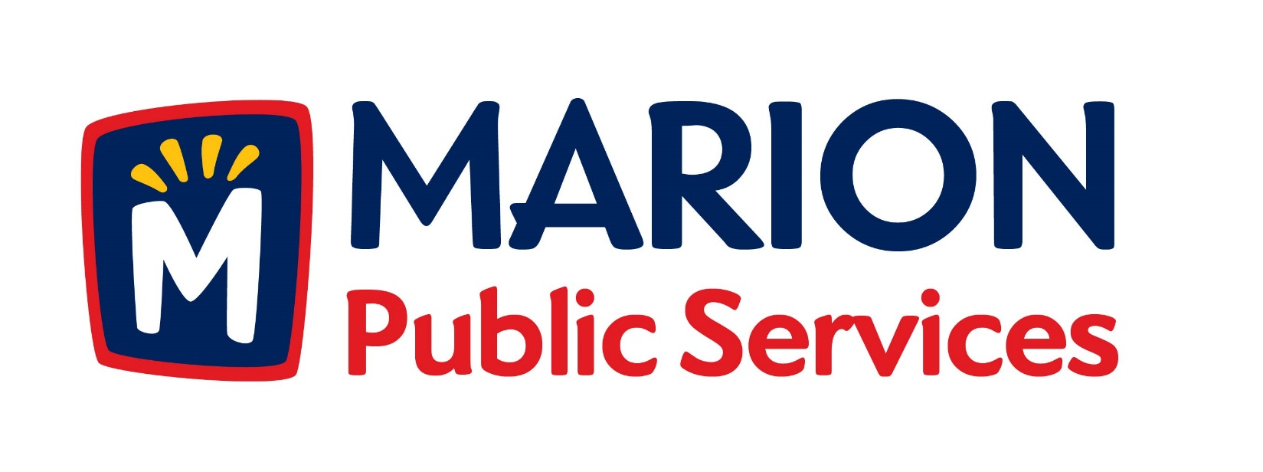

**Minutes**

**Public Services Board**

**City of Marion**

**Tuesday, September 8, 2015**

Present: Craig Adamson, Tom Padley Mark Morgan, Colleen Prokop, and Kevin Morgan

Staff: Ryan Miller and Diane Toy

1. Approval of August 2015 Minutes.
2. Motion to Approve house Pickup Request:
   1. Kula – 980 27th St
3. Motion to Approve Waiver of Solid Waste Fees – Unit Vacancy.
   1. Berridge – 2139 Echo Hill Rd
4. Presentation on Public Service Integrated Fleet Technologies.
5. Discussion on proposals for Public Service Chassis Development Program.
6. Update on Public Service Facility Development.
7. Old Business/New Business.
8. Adjournment.

**Minutes**

**Public Services Board**

**City of Marion**

**Tuesday, September 8, 2015**

**Continued**

ITEM 1 Approval of August 2015 Minutes

Craig Adamson called to order the regular meeting of the Public Service Board on Tuesday, September 8, 2015 at 12:05 PM. A motion to approve the August 2015 minutes was made by Mark Morgan, seconded by Kevin Morgan, approved by all, Motion carried.

ITEM 2 Motion to Approve House Pickup

A request for a house pickup at 980 27th St., resident is elderly and has health issues and lives alone. Staff has recommended that this resident become a house pick up. A motion was made by Mark Morgan, seconded by Kevin Morgan, all members agreed, Motion carried.

ITEM 3 Motion to Approve Waiver of Solid Waste Fee – Unit Vacancy

Ryan updated the PS Board about the waiver for Solid Waste Fee for unit vacancy, they must now be vacant for 180 days before they can apply to have the fees waived. The Water Department just purchased new software and it is now very difficult to manage fee charges. Ryan also explained how the utilities work – the solid waste truck still drives down the street, sometimes the resident will return early and put out garbage and recycling the driver has no way of knowing who is paying and who is not. The fees also pay for the recycling and compost operations. The property at 2139 Echo Hill Rd has been vacant for a year. A motion was made by Mark Morgan, seconded by Colleen Prokup, and all Board members are in favor, Motion carried.

**Minutes**

**Public Services Board**

**City of Marion**

**Tuesday, September 8, 2015**

**Continued**

ITEM 4 Presentation on Public Service Integrated Fleet Technologies

Ryan updated the PS Board about Verizon Wireless Partnership, they want to install small cell architecture on the decorative light poles. We will control the build out and how it looks, we are buying new light poles. There will not be any located in the Uptown area. We have a goal to have community benefits (every student can have internet connection for free) and we would like to branch out to the school districts so we can all benefit from the service and reduced cost.

We will be able to integrate smart street lighting into the grid, which will include advanced monitoring, remote control. This will also work with Integrated Fleet Technologies, we will be able to track our fleet and see the different pieces of equipment in real time and will be able to get reports. Each piece of equipment / vehicle can be fitted with Fleet software that will integrate with our traffic system and will have the capability to do GPS, the software is cloud based and will be able to give a drive the directions on how to run the plow or garbage route to a sub or new driver. Ryan would like to share this program with the school districts once we have our fleet on line.

IMON will be installing WIFI in the Uptown and Parks, they will be the owner of the network and we will split the cost. The WIFI was taken down because of illegal downloads from a public computer.

**Minutes**

**Public Services Board**

**City of Marion**

**Tuesday, September 8, 2015**

**Continued**

ITEM 5 Discussion on proposals for Public Service Chassis Development Program

The new chassis are for the mobility of the unit and flexibility, we will be able to have interchangeable boxes on 1 chassis, is designed for a longer life of the trucks. GVM out of Pennsylvania and a new company out of Oshkosh, this company builds solid waste, cement and fire trucks, they sell to airports and the trucks are the same width as a current dump truck and they work with Highway Equipment Company. We will look at leasing equipment verses out right buying.

ITEM 6 Update on Public Service Facility Development

Ryan updated the PS Board about the plans for the new facility, that they are very flexible for growth and change. What is the best fit for the department and how can we use our resources best and infrastructure. How do we use the land and still maintain the wetlands and timber?

ITEM 7 Old Business / New Business.

We are starting a 501C non-profit flag program to put flags up on the new city owned poles. Want to expand the program that a person can buy a flag / donate a flag.

Library project expansion: the information is not getting out to the residents in a timely and clear understanding of what the plans are. How do we get the information out?

**Minutes**

**Public Services Board**

**City of Marion**

**Tuesday, September 8, 2015**

**Continued**

Meeting was adjourned at 1:40PM by Craig Adamson. A motion was made by Mark Morgan, seconded by Tom Padley, and all Board members are in favor, Motion carried.

Next PSB meeting is scheduled for Tuesday, October 13, 2015 at noon.

Respectfully submitted by:

____________________

Ryan Miller

Public Service Director

RM/dpt