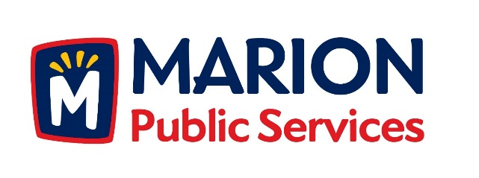

**CITY OF MARION PUBLIC SERVICE BOARD**

**AGENDA**

**Noon**

**December 8th, 2015**

1. Approval of November Minutes.
2. Motion to Approve House Pickup Request.
   1. Nassif/Collins-3030 Diamond Lane

3. Motion to file application for financial assistance for fuel systems development:

A. Renewable Fuel Infrastructure Program-IDALS

B. Biofuels Infrastructure Program-USDA

4. Motion directing staff to complete plans and specifications for the Eco-Industrial Park Development.

5. Discussion regarding Public Services Budget for 2016/2017 Fiscal Year

6. Old Business/New Business.

7. Adjournment.